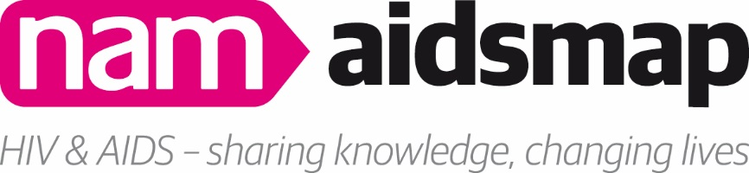
Information for potential trustees
NAM is one of the world’s foremost providers of information on HIV and AIDS. Our information is aimed at two main audiences: people living with HIV; and professionals working in the field such as doctors, other healthcare workers, community advocates and HIV organisation staff and volunteers.
This is a challenging time for HIV organisations and the charitable sector. NAM’s trustees play a crucial role in advancing the charity’s purposes, overseeing the organisation’s strategic direction and protecting its assets and interests.
NAM's board of trustees uses its wide range of experience, specialisms and interests in HIV, at personal and corporate levels, to provide strategic leadership for the charity. More information about our trustees can be found here.
The trustees intend that the board should collectively provide a mix of skills, experience, qualities and knowledge to enable NAM to respond effectively to the challenges and opportunities faced by the organisation and, in line with NAM's mission, to ensure the organisation remains rooted in the experience of those most affected by HIV and AIDS.
Currently, NAM is particularly looking to increase the representation of trans people, women and people from sub-Saharan African communities on our board.
A full outline of the role, and a person specification, can be found below.
The trustees receive no remuneration for their work with NAM.
Time commitment: 3-6 hours every 2 months.
NAM’s trustees’ meetings are currently being held virtually.
If you wish to apply to become a trustee of NAM, please send your CV, along with a brief explanation of why you are interested in becoming a trustee to info@nam.org.uk.

Role description
The Charity Commission produces a straightforward introduction to what becoming a trustee of a charity involves, which is viewable here.
The specific responsibilities of NAM’s trustees are:
- Ensuring that NAM complies with its governing document, charity law, company law and any other relevant legislation or regulations.
- Ensuring that the organisation pursues its charitable objects as defined in its governing document.
- Ensuring that NAM applies its resources exclusively in furtherance of its objects.
- Contributing actively to the board of trustees’ role of giving firm strategic direction to the organisation, setting overall policy, defining goals, setting targets and evaluating performance against targets.
- Safeguarding and promoting the good name and values of NAM.
- Ensuring the financial stability of NAM.
- Protecting and managing the property of the organisation and ensuring the proper investment of NAM’s funds.
- Appointing and supporting the Executive Director and monitoring his or her performance.
- Bringing specific knowledge or expertise they possess to help the board of trustees to reach sound decisions. This involves scrutinising papers, leading discussions, focusing on key issues, and providing advice and guidance requested by the board and/or staff on new initiatives or other relevant issues in which the trustee has special expertise.

Person specification
We are looking for individuals with:
- A commitment to NAM and its work.
- Expertise, knowledge or skills in one or more of the following areas:

  - Legal issues for charities
  - Human resources
  - HIV prevention and support needs for sub-Saharan African communities
  - HIV prevention and support needs for trans people
  - New technologies for delivering information
  - Income generation, especially via trusts & foundations, and legacy fund-raising
  - Charity governance & management
  - External relations & marketing (including social media)
  - Quality standards
  - Strategy development and implementation
  - Prevention of HIV transmission
  - Information services for older people
  - Long-term condition management
  - Hepatitis C
  - Life with HIV

- An understanding and acceptance of the legal duties, responsibilities and liabilities of trusteeship
- A willingness to devote the necessary time and effort to the duties of a trustee
- Strategic vision.
- Good, independent judgement.
- An ability to think creatively.
- The courage and willingness to speak their mind.
- An ability to work effectively as a member of a team.
- An ability to adhere to the Nolan Committee’s principles for public life. These are selflessness, integrity, objectivity, accountability, openness, honesty and leadership.

Currently, NAM is particularly looking to increase the representation of trans people, women and people from sub-Saharan African communities on our board.

