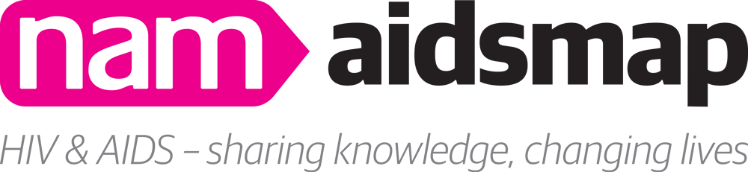

NAM is dedicated to delivering the highest quality information about HIV, hepatitis and associated conditions to clinicians, healthcare workers and people living with HIV across the globe. NAM’s resources, including aidsmap – Europe’s premier, independent HIV treatment information website – rely on a small pool of talented and experienced scientific writers. These writers are responsible for ensuring that HIV-related information from journals, conferences and other sources is accessible to a range of audiences.
As we develop as an organisation we are eager to empower a new generation of writers and communicators. We look to increase the size and diversity of NAM’s editorial team, to better reflect those communities with the highest HIV prevalence.
The Emerging Voices programme has been developed to ensure new writers are given opportunities to develop their skills in a professional and supportive environment, enabling them to gain experience and access employment opportunities within the fields of journalism, public health or scientific reporting.
Successful candidates will help NAM’s staff to write, update and edit information and articles on aidsmap. This may include news articles, email bulletins, factsheets and other web pages. Our editors will provide coaching and support, including suggestions of additional training if appropriate.
We will pay for published articles at our usual rates. This is on the condition that they have not needed intensive editing by NAM’s staff before publication.
If you are interested in applying for a place on the Emerging Voices programme, please answer the following questions and email the completed form to info@nam.org.uk. Places on the programme are limited and we are unable to guarantee a place to all who apply.
You will be assessed on the merits of your application, including your writing style. Your answers should be clear, accessible and relevant, as this is part of the criteria for this programme. Please do not provide responses longer than 200 words to any of the questions.

Why are you interested in this opportunity? How would you hope to use this opportunity in your future career?
What aspects of HIV news are you most interested in covering? This may relate to different aspects of HIV that we report, such as HIV treatment, co-morbidities, HIV prevention, epidemiology or stigma, or to different groups affected by the virus, e.g. mothers, migrant communities, gay and bisexual men, trans men and women, or injecting drug users. Please explain the reasons for your interest.
What do you believe to be the most important requirements for a news story on aidsmap.com?
What skills do you have which you believe would be most valuable to you in engaging with this programme?
In relation to writing for us, in which areas do you feel you may need a greater level of support or training?
NB we are looking to help and support people in their development; your answer will help us to consider how we can best do this.
Give examples from your work or personal experience about your abilities relating to the following skills:
- Meeting deadlines.
- Working independently and with autonomy.
- Working collaboratively.
- Responding to feedback.

Equal Opportunities Monitoring
Name:
Age:
Gender:
Is your gender identity the same as the sex you were assigned at birth?
How would you describe your sexuality?
How would you describe your ethnicity?
Do you consider yourself to have a disability or health condition?

